Kubernetes Task-04
- Deploy an application using a Deployment with 3 replicas and a rolling update strategy.
  - Create deployment.yaml
apiVersion: apps/v1
kind: Deployment
metadata:
name: my-app-deployment
labels:
app: my-app
spec:
replicas: 3
selector:
matchLabels:
app: my-app
strategy:
type: RollingUpdate
rollingUpdate:
maxUnavailable: 1
maxSurge: 1
template:
metadata:
labels:
app: my-app
spec:
containers:
- name: my-app-container
image: nginx:latest
ports:
- containerPort: 80
  - Apply the Deployment
kubectl apply -f deployment.yaml
  - Verify
kubectl get deployments
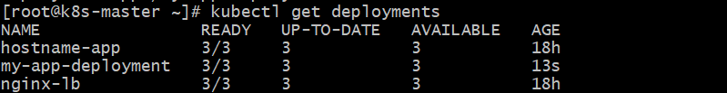
kubectl get pods
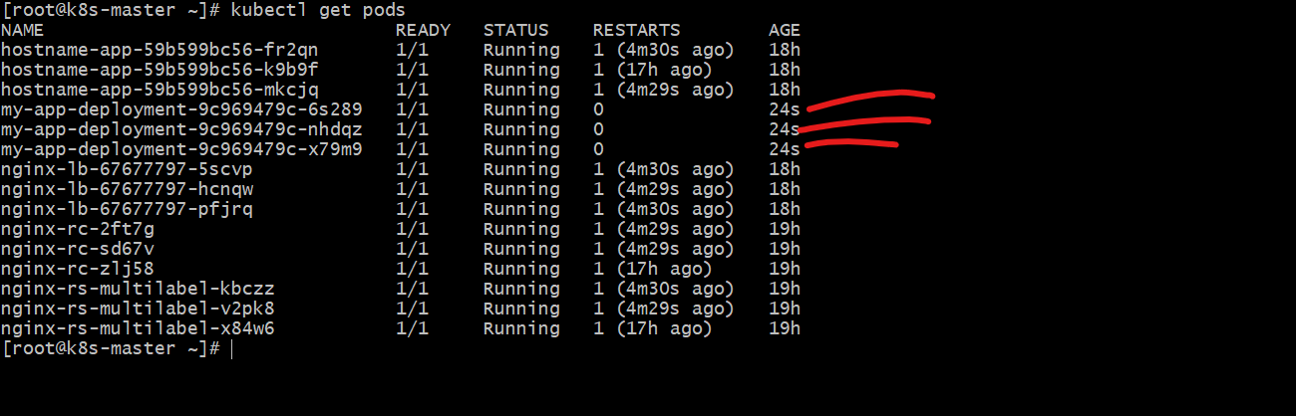

- Configure a Deployment with a Recreate strategy and observe the downtime.
  - Create YAML file
Save as recreate-deploy.yaml
apiVersion: apps/v1
kind: Deployment
metadata:
name: nginx-recreate
spec:
replicas: 3
strategy:
type: Recreate
selector:
matchLabels:
app: nginx-recreate
template:
metadata:
labels:
app: nginx-recreate
spec:
containers:
- name: nginx
image: nginx:1.25
ports:
- containerPort: 80
  - Apply it
kubectl apply -f recreate-deploy.yaml
kubectl get deploy
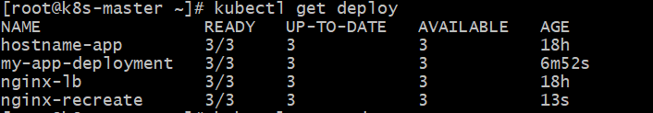
kubectl get pods -w
You should see 3 pods running.
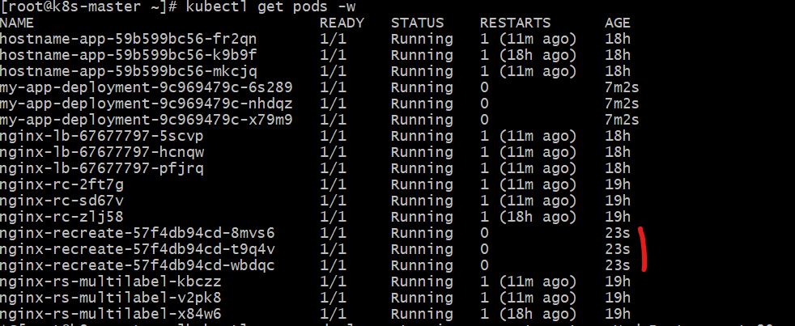
  - Expose the Deployment
kubectl expose deployment nginx-recreate --type=NodePort --port=80 --target-port=80
kubectl get svc
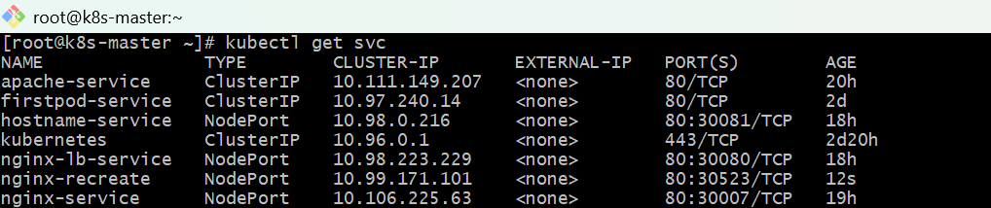

Check service details:
kubectl get svc nginx-recreate
Open the app in browser
Use:
http://<NodeIP>:<NodePort>
Ex:
http://13.61.173.74:30523
You should see the nginx welcome page.
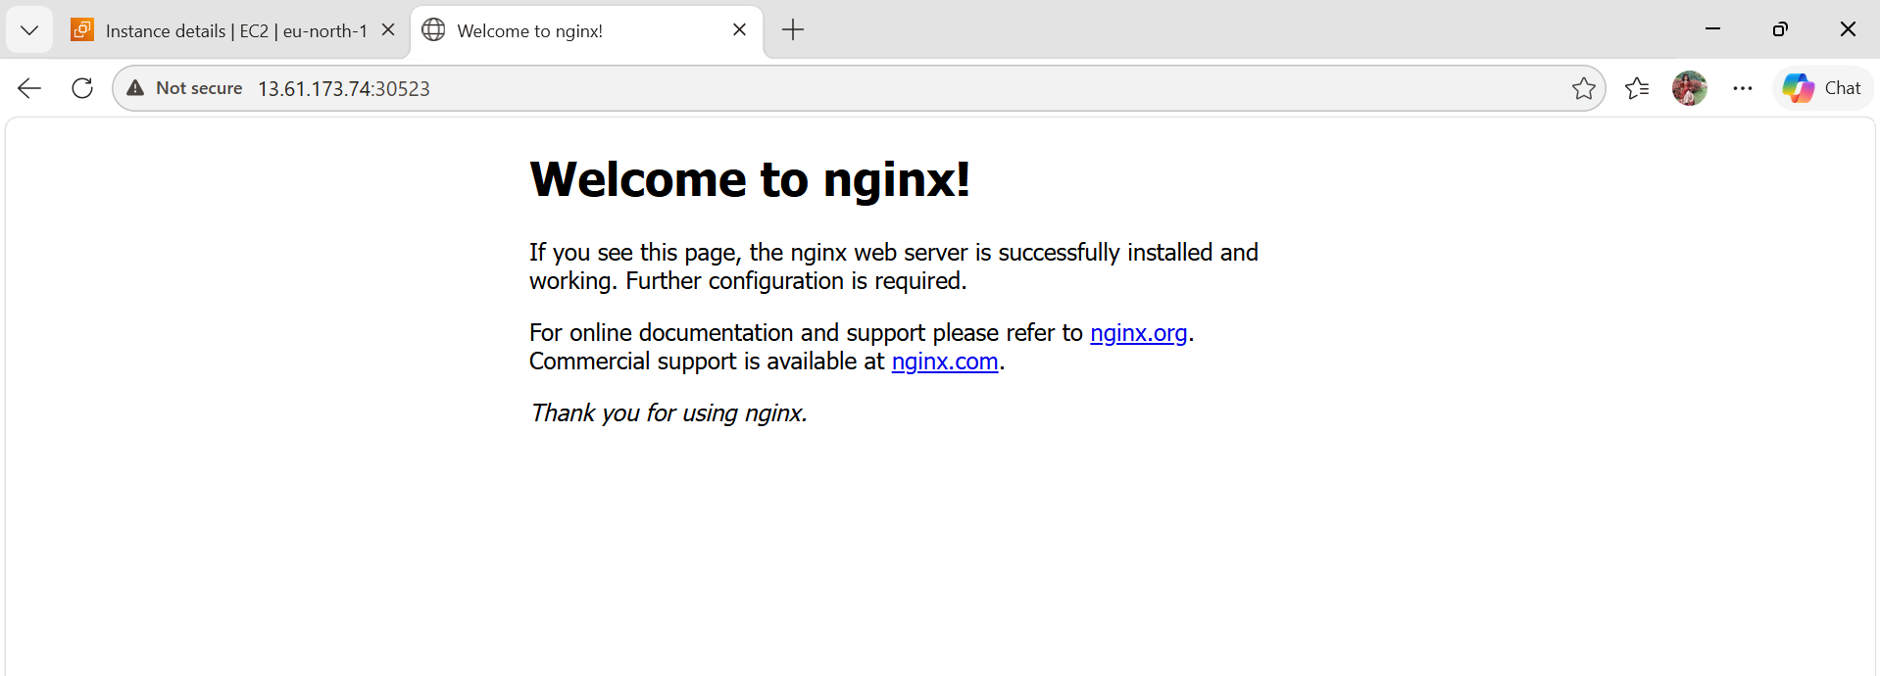
  - Update the Deployment image to trigger recreate
kubectl set image deployment/nginx-recreate nginx=nginx:1.26
Now watch pods:
kubectl get pods -w
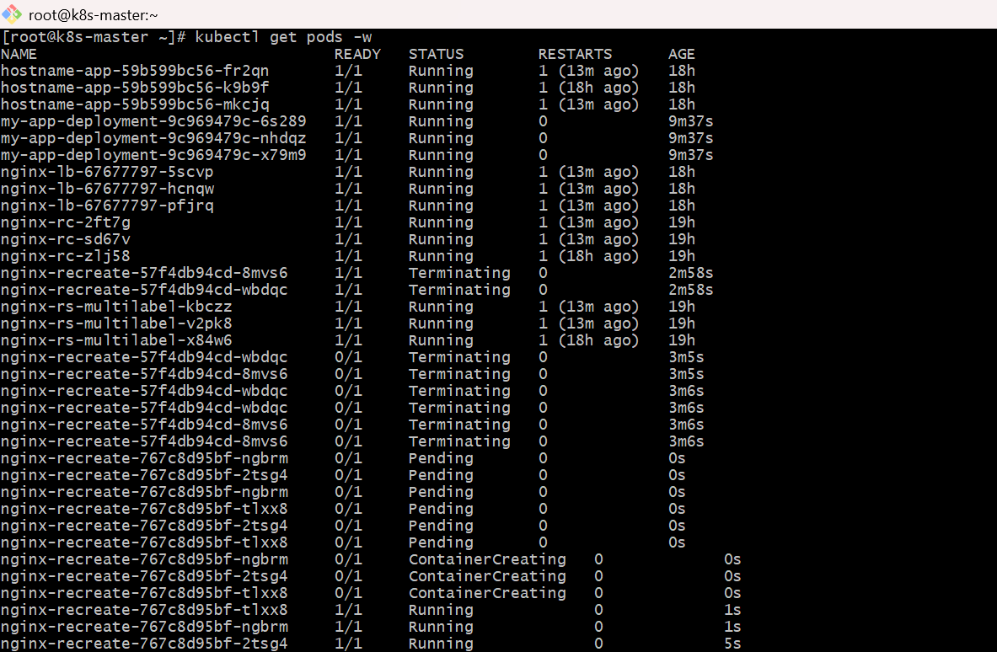
  - Observe downtime
Because strategy is Recreate:
- first old 3 pods are terminated
- then new pods are created
During that gap, service has no backend pods, so app becomes temporarily unavailable.
You can test continuously from terminal:
while true; do curl http://<NodeIP>:<NodePort>; sleep 1; done
During update, you may see:
- connection refused
- timeout
- empty response for a few seconds
That is the downtime.
  - Verify strategy
kubectl describe deployment nginx-recreate
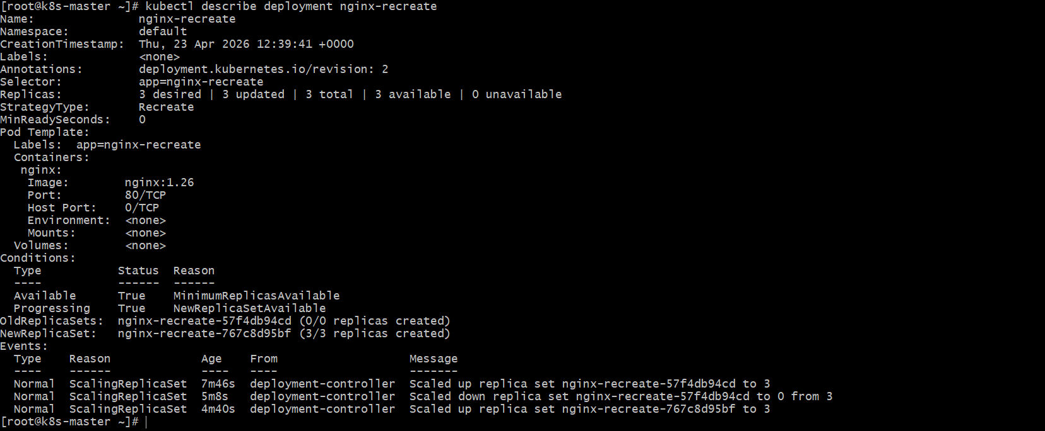
Look for:
StrategyType: Recreate

- Update an existing Deployment and perform a rollback to the previous version.
  - Create the Deployment first
Save as deploy.yaml
apiVersion: apps/v1
kind: Deployment
metadata:
name: nginx-deploy
spec:
replicas: 3
selector:
matchLabels:
app: nginx-deploy
template:
metadata:
labels:
app: nginx-deploy
spec:
containers:
- name: nginx
image: nginx:1.25
ports:
- containerPort: 80
Apply it:
kubectl apply -f deploy.yaml
kubectl get deploy
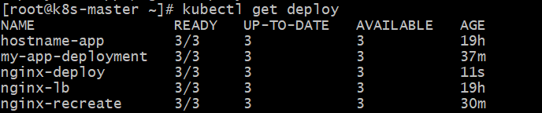
kubectl get pods
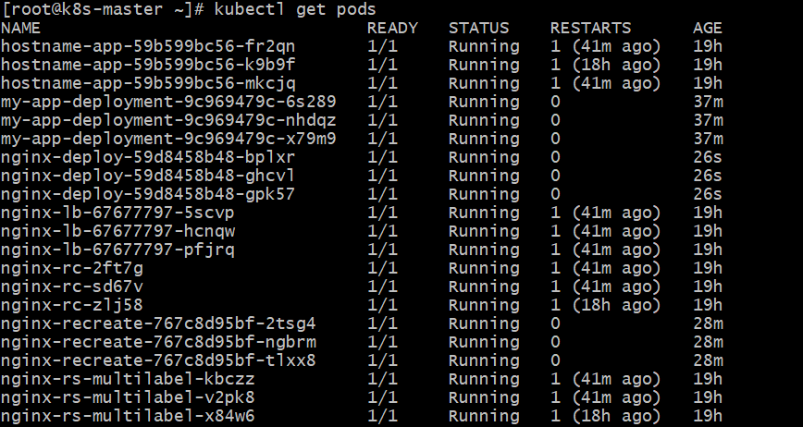
  - Check current image/version
kubectl describe deployment nginx-deploy
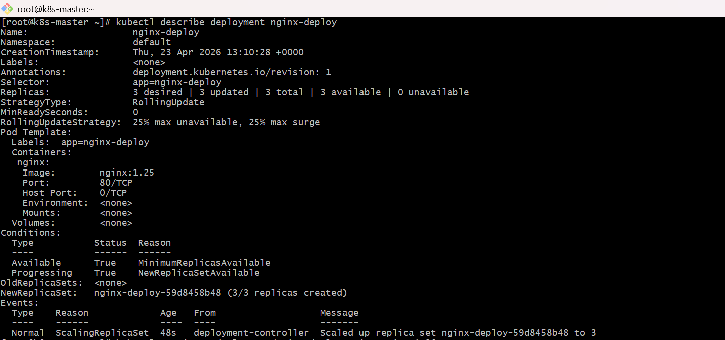
  - Update the Deployment to a new version
Change image from nginx:1.25 to nginx:1.26
kubectl set image deployment/nginx-deploy nginx=nginx:1.26
Check rollout status:
kubectl rollout status deployment/nginx-deploy
Check pods:
kubectl get pods
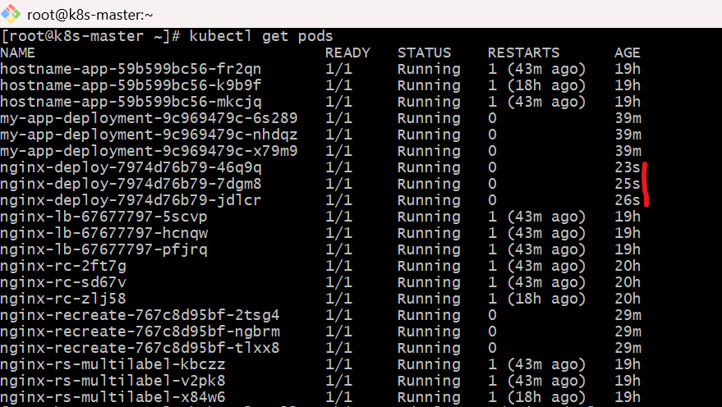
Check rollout history:
kubectl rollout history deployment/nginx-deploy
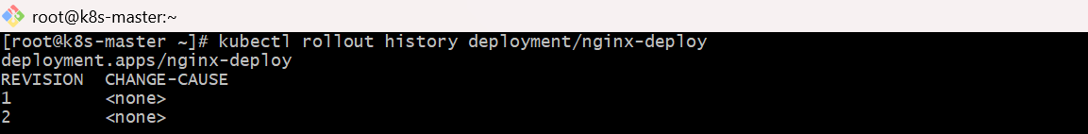
  - Roll back to previous version
kubectl rollout undo deployment/nginx-deploy
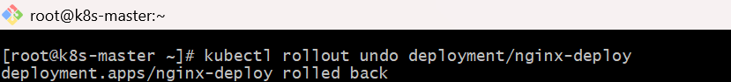
Again check status:
kubectl rollout status deployment/nginx-deploy
Check history:
kubectl rollout history deployment/nginx-deploy
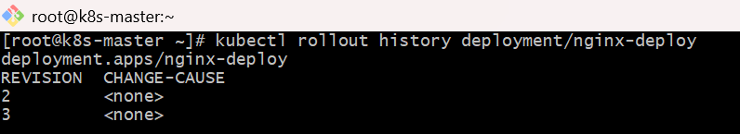
  - Verify rollback worked
kubectl describe deployment nginx-deploy
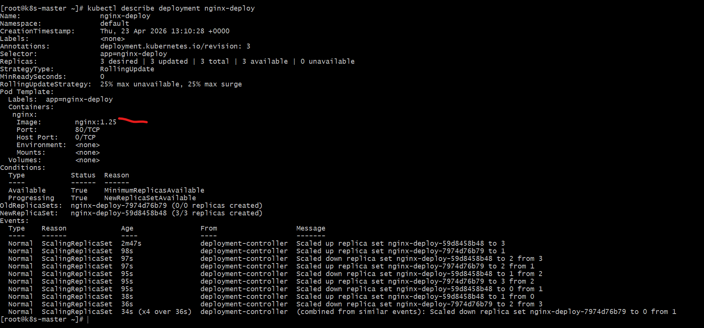
You should see image changed back to:
nginx:1.25

- Modify a Deployment to add resource requests and limits for CPU and memory.
Example YAML
vi deploy-resource.yaml
apiVersion: apps/v1
kind: Deployment
metadata:
name: nginx-deploy
spec:
replicas: 3
selector:
matchLabels:
app: nginx
template:
metadata:
labels:
app: nginx
spec:
containers:
- name: nginx
image: nginx
ports:
- containerPort: 80
resources:
requests:
cpu: "100m"
memory: "128Mi"
limits:
cpu: "200m"
memory: "256Mi"
Apply it
If deployment already exists:
kubectl apply -f deploy-resource.yaml
Add this inside the container section:
resources:
requests:
cpu: "100m"
memory: "128Mi"
limits:
cpu: "200m"
memory: "256Mi"
Verify
kubectl get deployment
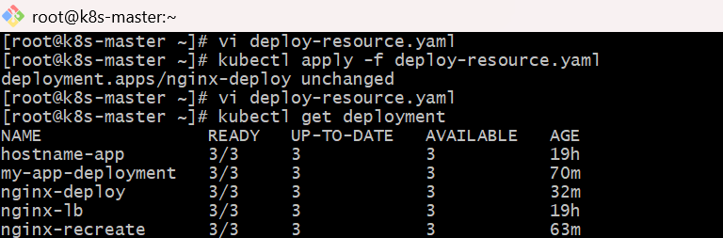
kubectl describe deployment nginx-deploy
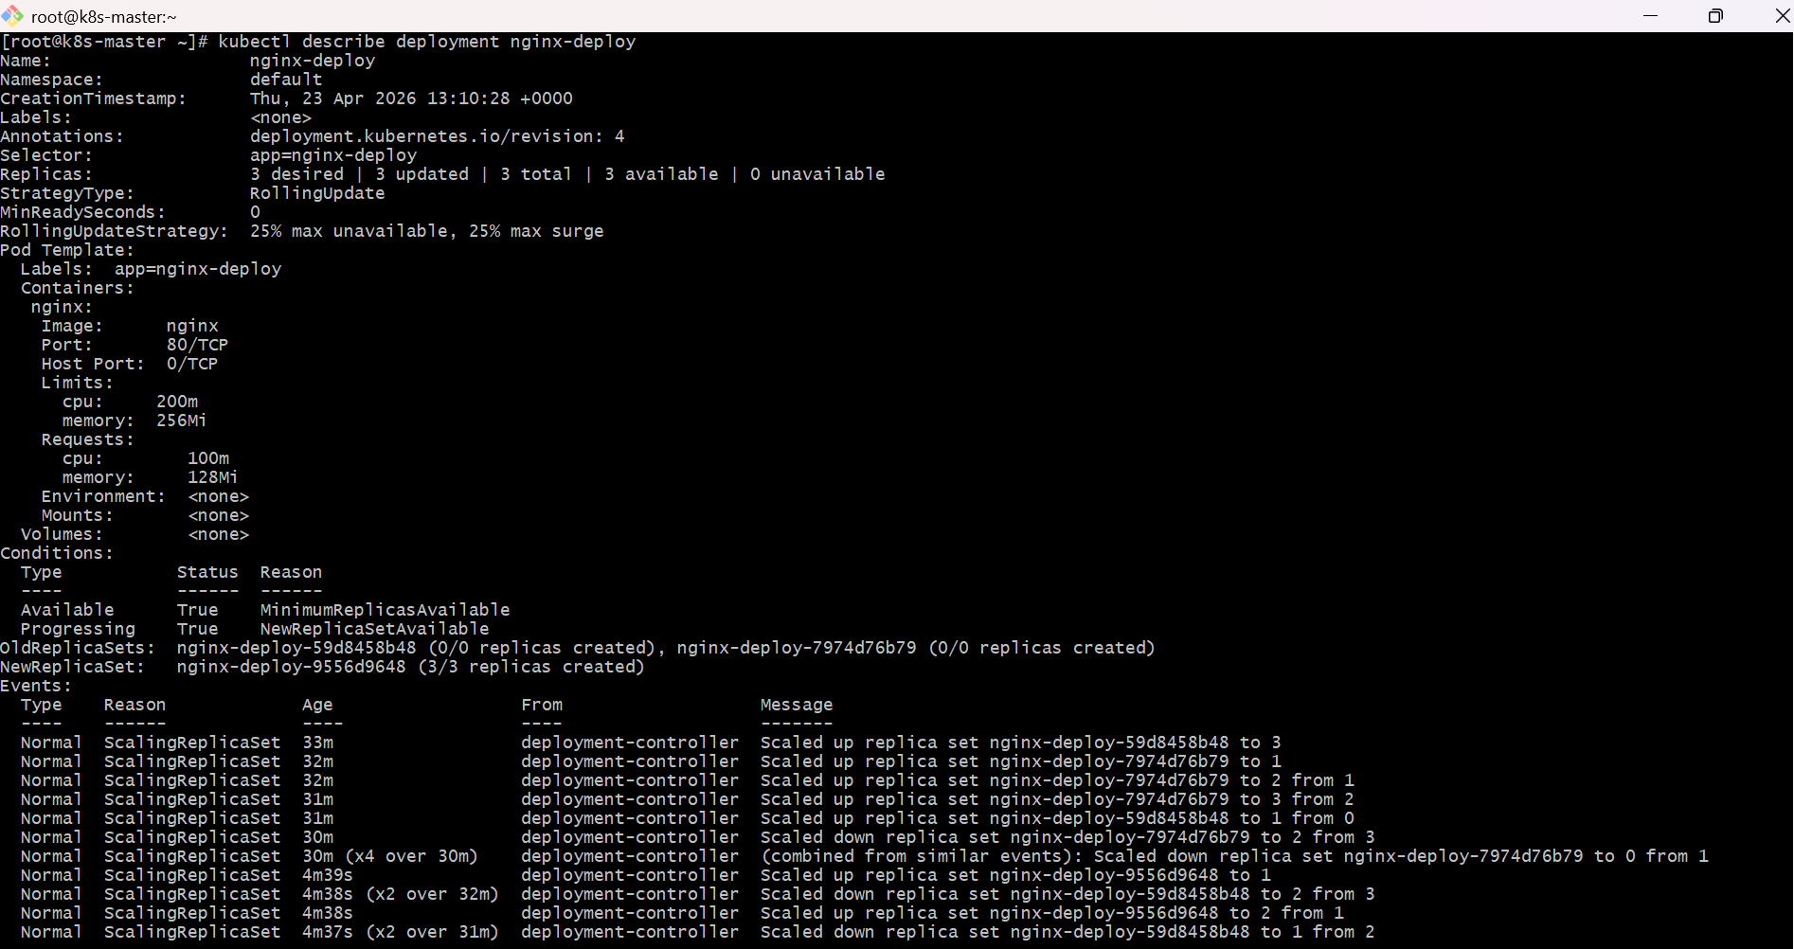
kubectl describe pod
To check pod names first:
kubectl get pods
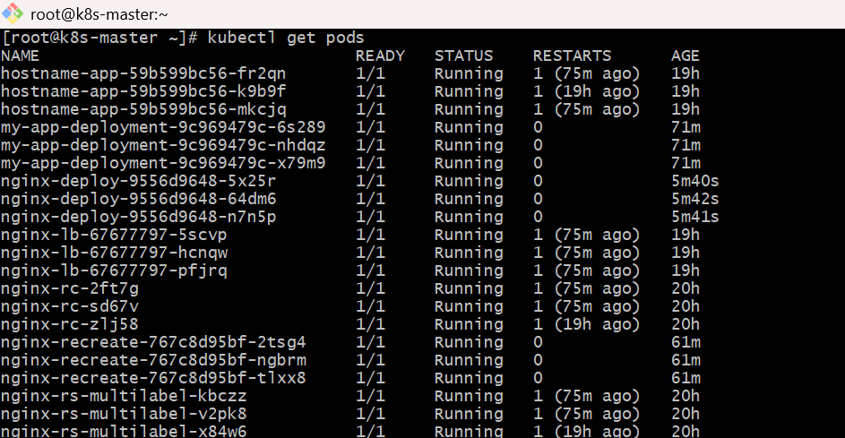
Then describe one pod:
kubectl describe pod <pod-name>
Look for:
Requests:
cpu: 100m
memory: 128Mi
Limits:
cpu: 200m
memory: 256Mi
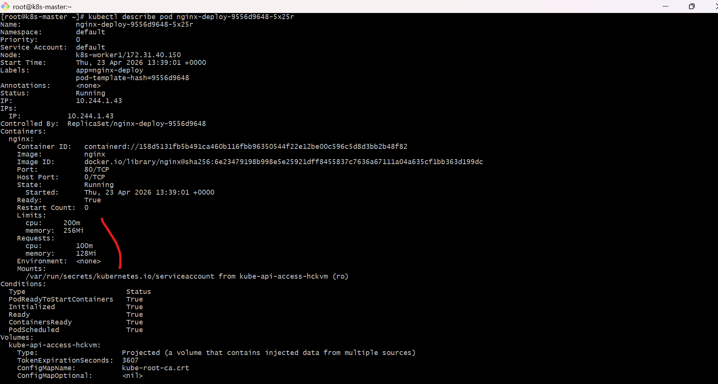
Useful command
To see full YAML of current deployment:
kubectl get deployment nginx-deploy -o yaml
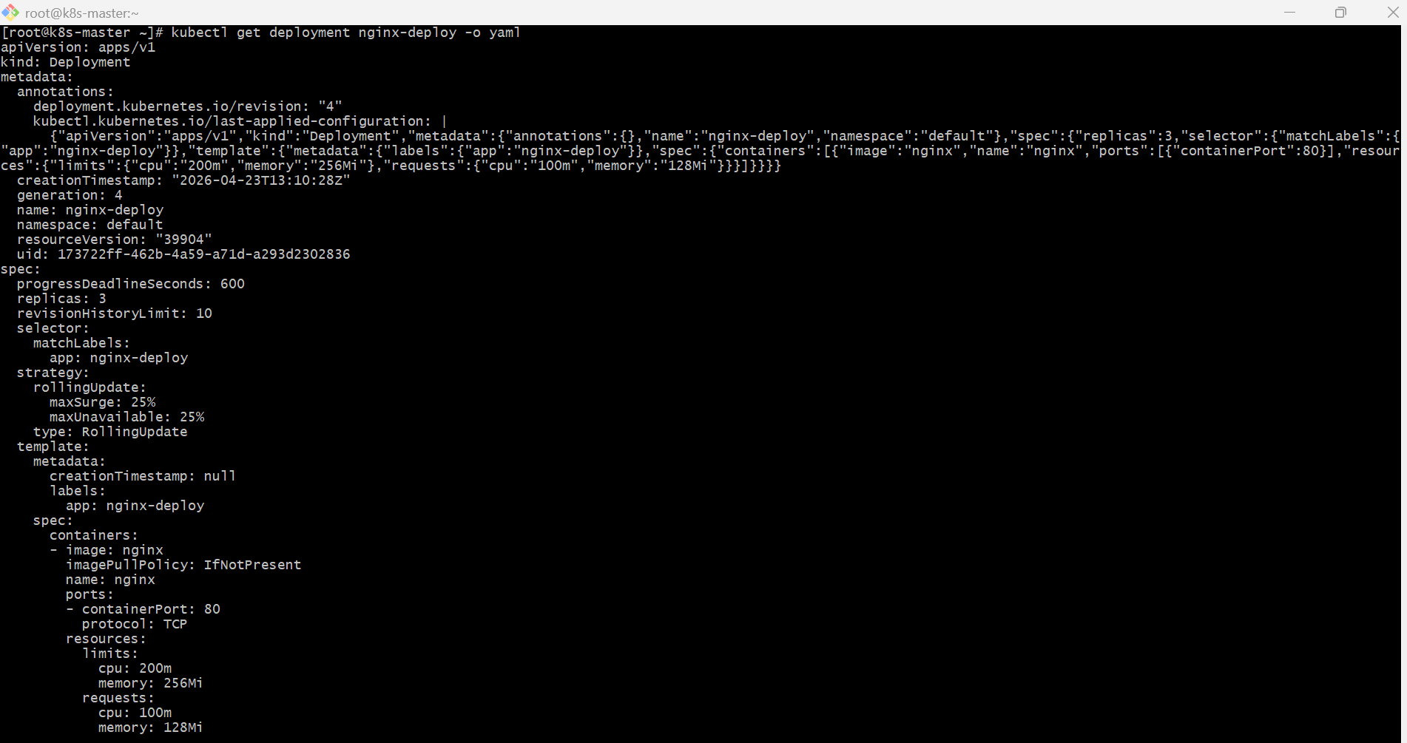
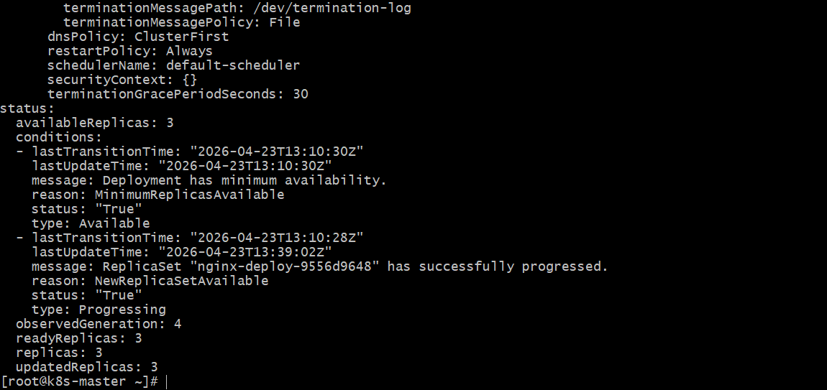

- Create a Deployment with MaxSurge and MaxUnavailable configurations.
  - YAML File (deployment-surge.yaml)
apiVersion: apps/v1
kind: Deployment
metadata:
name: nginx-surge-deploy
spec:
replicas: 3
selector:
matchLabels:
app: nginx-surge
strategy:
type: RollingUpdate
rollingUpdate:
maxSurge: 1
maxUnavailable: 1
template:
metadata:
labels:
app: nginx-surge
spec:
containers:
- name: nginx
image: nginx:1.25
ports:
- containerPort: 80
  - Apply Deployment
kubectl apply -f deployment-surge.yaml
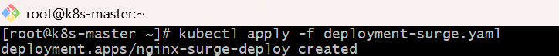
  - Verify Deployment
kubectl get deployments
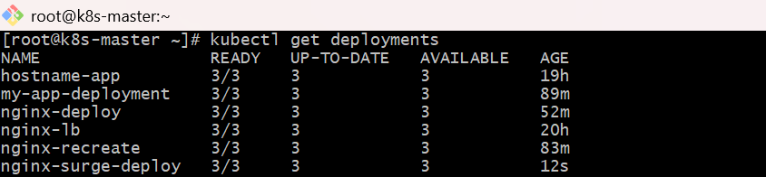
kubectl get pods
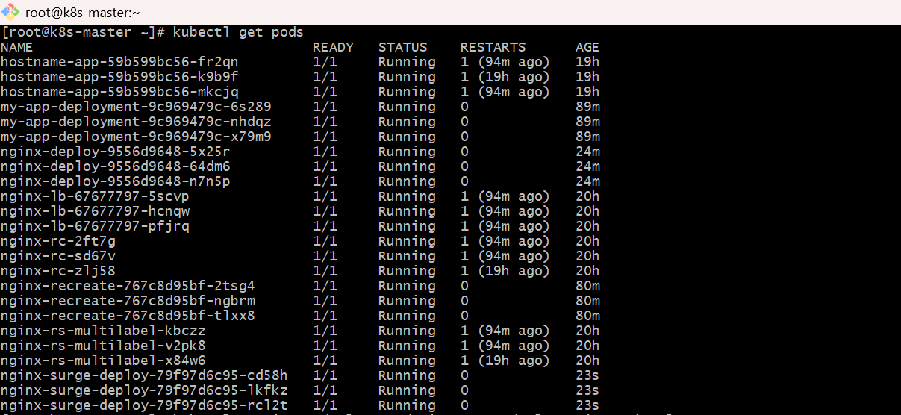
  - Test Rolling Update
Update image to trigger rollout:
kubectl set image deployment/nginx-surge-deploy nginx=nginx:latest
Check rollout:
kubectl rollout status deployment/nginx-surge-deploy

- Set up a Deployment with a custom revision history limit.
  - Create YAML File
vi revision-deployment.yaml
apiVersion: apps/v1
kind: Deployment
metadata:
name: revision-app
spec:
replicas: 3
revisionHistoryLimit: 5 # Custom limit
strategy:
type: RollingUpdate
rollingUpdate:
maxSurge: 1
maxUnavailable: 1
selector:
matchLabels:
app: revision-app
template:
metadata:
labels:
app: revision-app
spec:
containers:
- name: nginx
image: nginx:1.24
ports:
- containerPort: 80
  - Apply Deployment
kubectl apply -f revision-deployment.yaml
  - Verify Deployment
kubectl get deployment revision-app
  - Create Multiple Revisions
Update image multiple times:
kubectl set image deployment/revision-app nginx=nginx:1.25
kubectl set image deployment/revision-app nginx=nginx:1.26
kubectl set image deployment/revision-app nginx=nginx:1.27
kubectl set image deployment/revision-app nginx=nginx:1.28
kubectl set image deployment/revision-app nginx=nginx:1.29
kubectl set image deployment/revision-app nginx=nginx:1.30
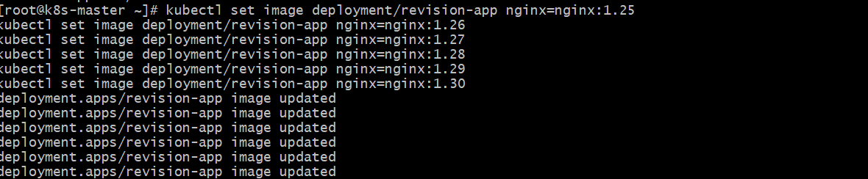
  - Check ReplicaSets
kubectl get rs
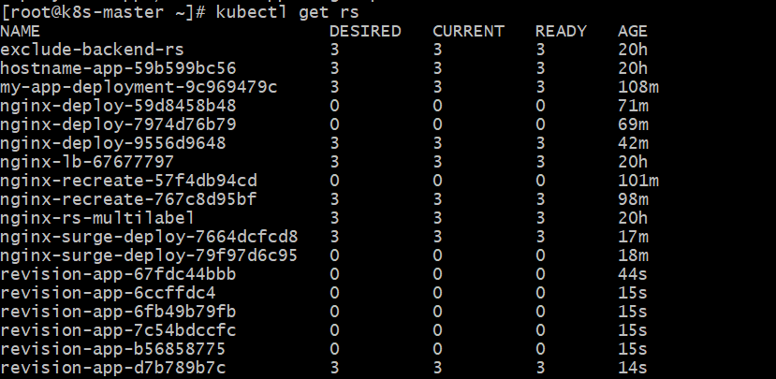
  - Check Rollout History
kubectl rollout history deployment revision-app
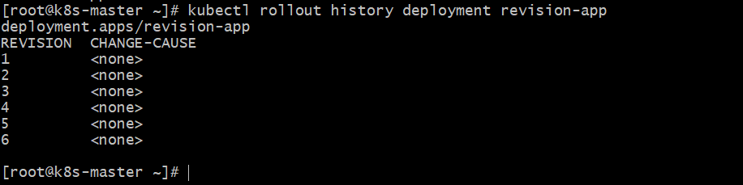
- Pause a Deployment during an update, and then resume it.
  - Create vi nginx-pause-demo.yaml
apiVersion: apps/v1
kind: Deployment
metadata:
name: nginx-pause-demo
spec:
replicas: 3
selector:
matchLabels:
app: nginx-pause-demo
template:
metadata:
labels:
app: nginx-pause-demo
spec:
containers:
- name: nginx
image: nginx:1.24
ports:
- containerPort: 80
Apply it:
kubectl apply -f nginx-pause-demo.yaml
kubectl get deploy
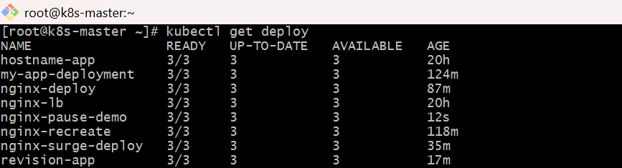
kubectl get pods
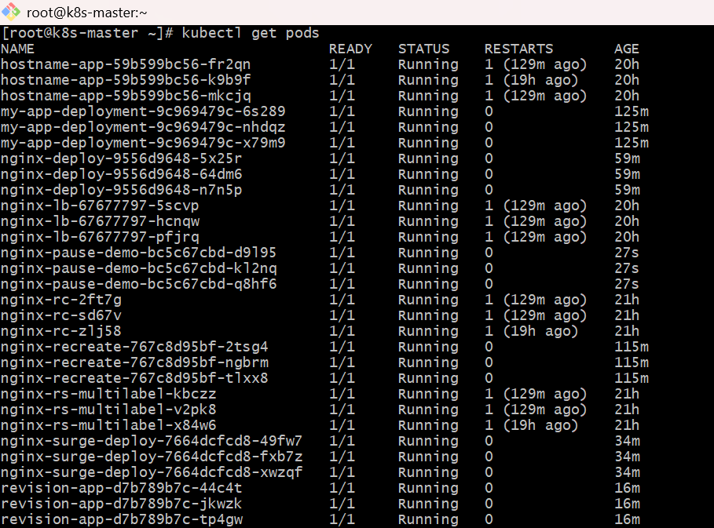
  - Pause the Deployment
kubectl rollout pause deployment/nginx-pause-demo
Check:
kubectl describe deployment nginx-pause-demo
You should see that the deployment is paused.
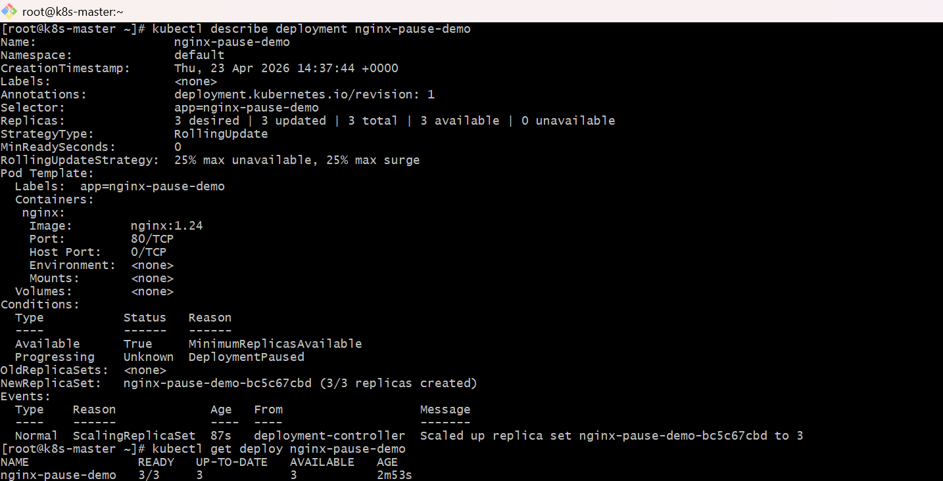
Also verify:
kubectl get deploy nginx-pause-demo
  - Make another change while paused
For example, add/change replicas:
kubectl scale deployment nginx-pause-demo --replicas=5
  - Resume the Deployment
kubectl rollout resume deployment/nginx-pause-demo
Check rollout again:
kubectl rollout status deployment/nginx-pause-demo
Verify
kubectl get deployment nginx-pause-demo
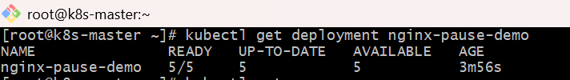
kubectl get rs
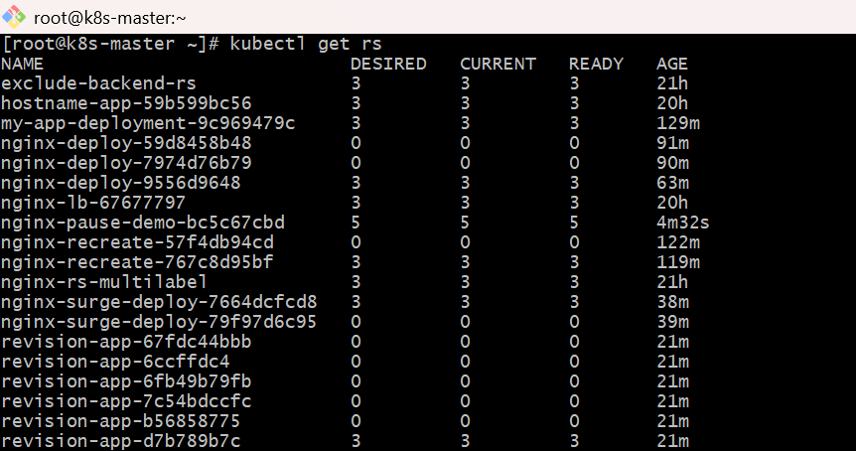
kubectl get pods -o wide
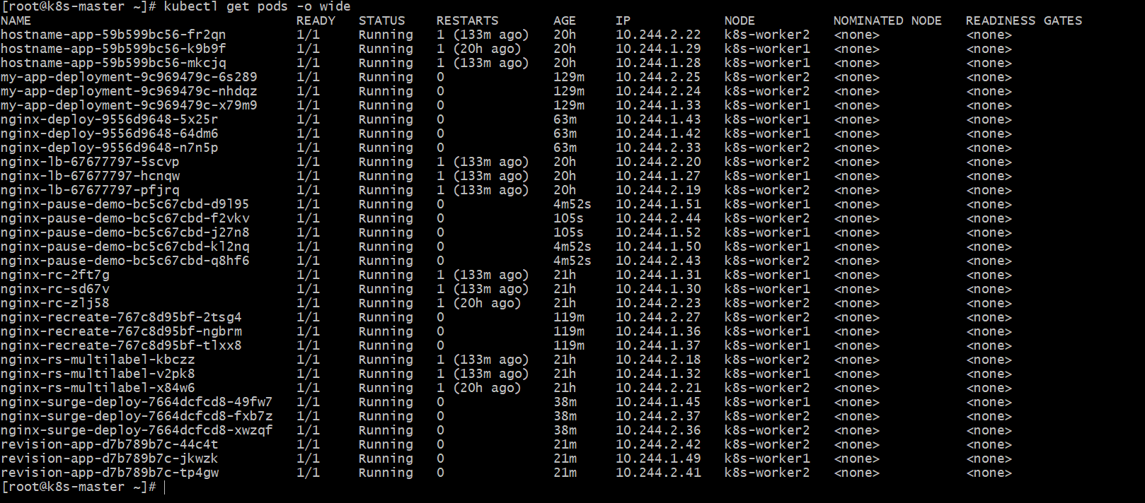

- Create a pod using resource requests for memory and CPU, and observe how the scheduler assigns it to a node.
  - Create YAML file
Save as resource-pod.yaml
apiVersion: v1
kind: Pod
metadata:
name: resource-pod
spec:
containers:
- name: nginx
image: nginx
resources:
requests:
memory: "128Mi"
cpu: "250m"
limits:
memory: "256Mi"
cpu: "500m"
  - Apply the pod
kubectl apply -f resource-pod.yaml
  - Check pod status
kubectl get pods -o wide
You will see which node the pod is assigned to in the NODE column.
Example:
NAME READY STATUS RESTARTS AGE IP NODE
resource-pod 1/1 Running 0 20s 10.244.1.10 k8s-worker1
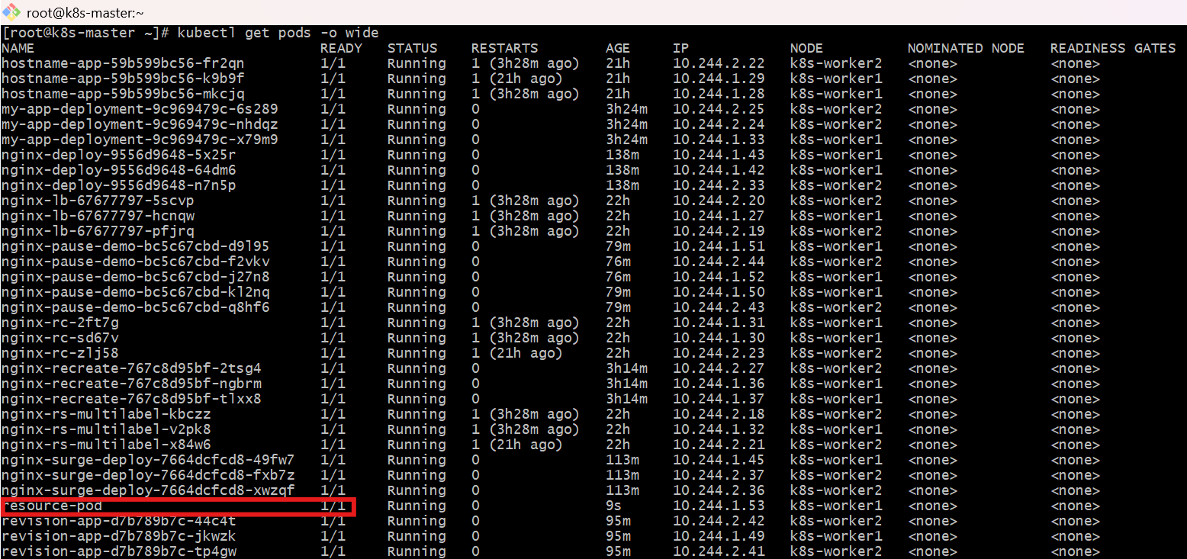
  - Observe scheduler decision
Run:
kubectl describe pod resource-pod
Look at these sections:
Node
Node: k8s-worker1/192.168.1.20
Events
Events:
Type Reason Age From Message
---- ------ ---- ---- -------
Normal Scheduled 10s default-scheduler Successfully assigned default/resource-pod to k8s-worker1
Normal Pulled 8s kubelet Container image "nginx" already present on machine
Normal Created 7s kubelet Created container nginx
Normal Started 7s kubelet Started container nginx
This shows the scheduler selected that node.
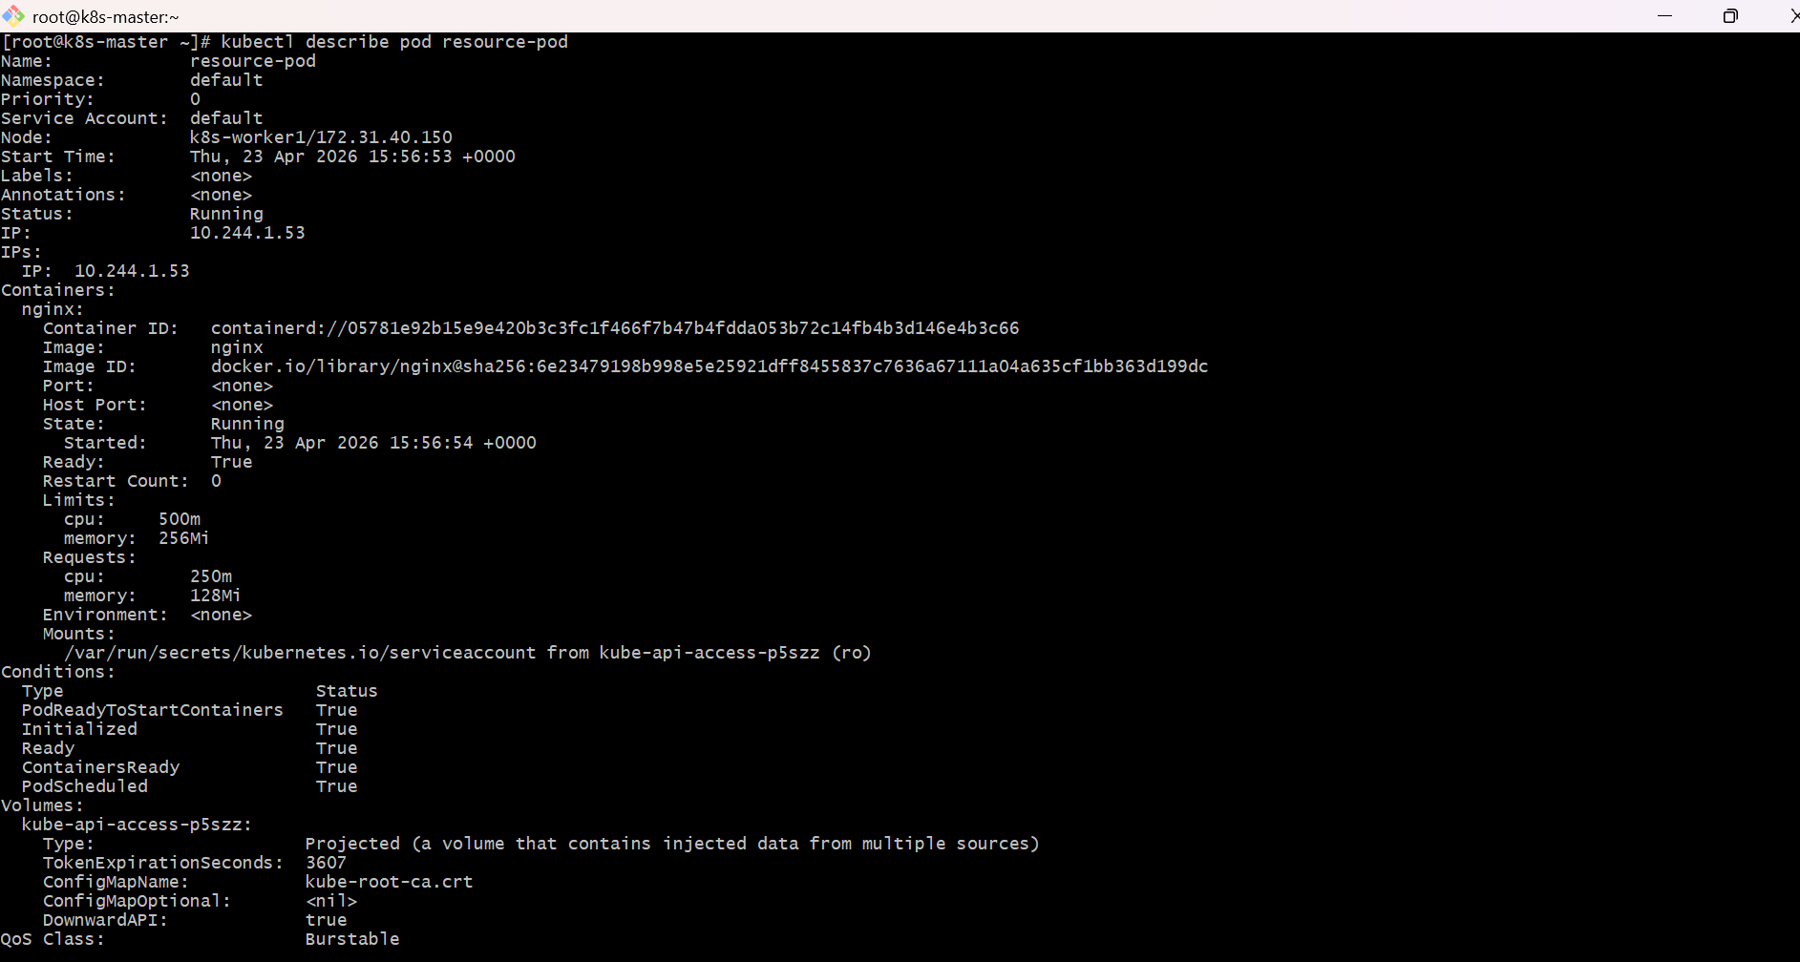
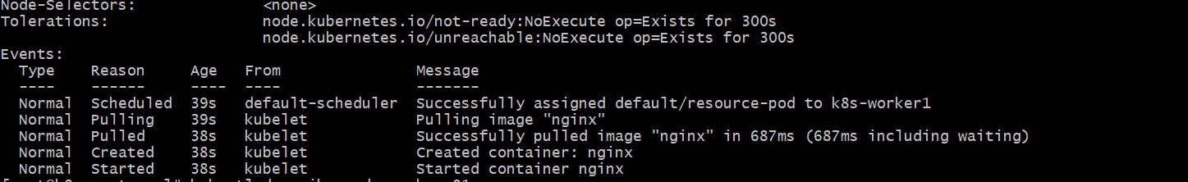
  - Check node resources
To understand why it was placed there:
kubectl describe node k8s-worker1
Look for:
Allocated resources:
Resource Requests Limits
-------- -------- ------
cpu ...
memory ...
The scheduler places the pod on a node that has enough requested CPU and memory available.
Important point
- requests = minimum resources the scheduler uses for placement
- limits = maximum resources the container can use
So here:
- CPU request = 250m means 0.25 CPU
- Memory request = 128Mi
The pod will only be scheduled onto a node that can provide at least that much free CPU and memory.
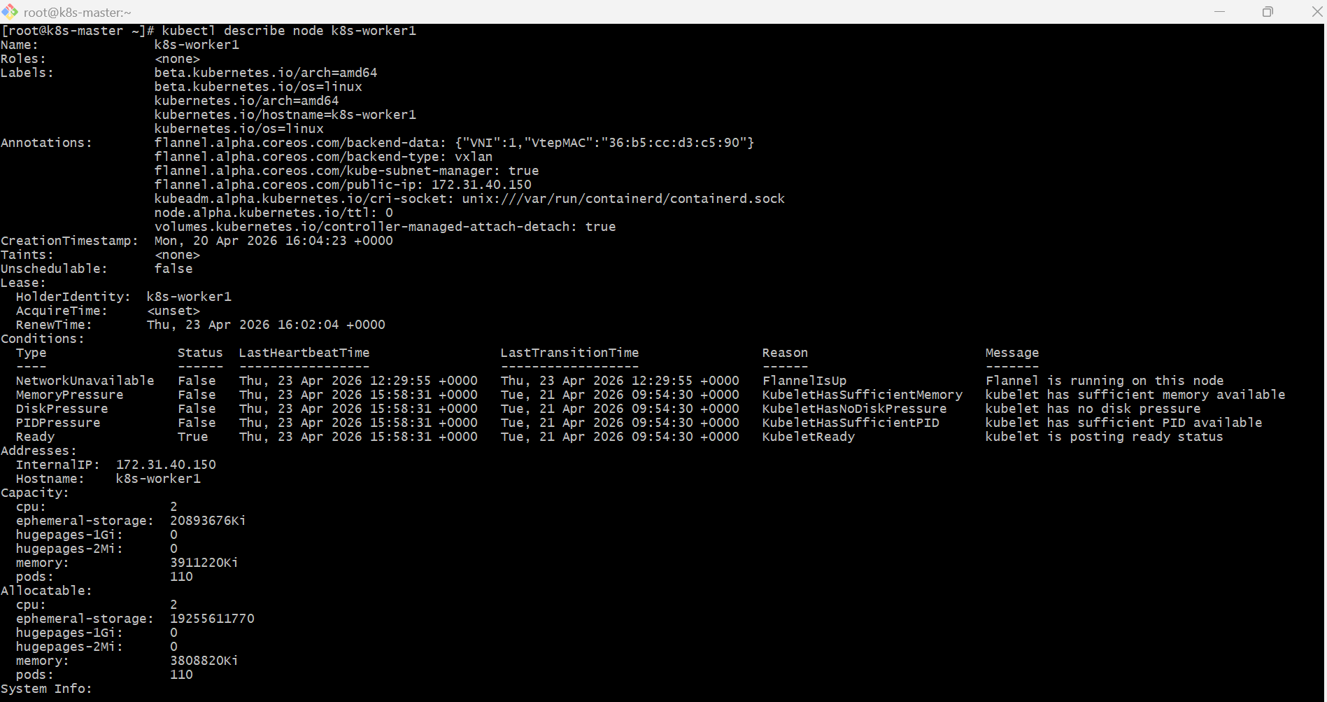
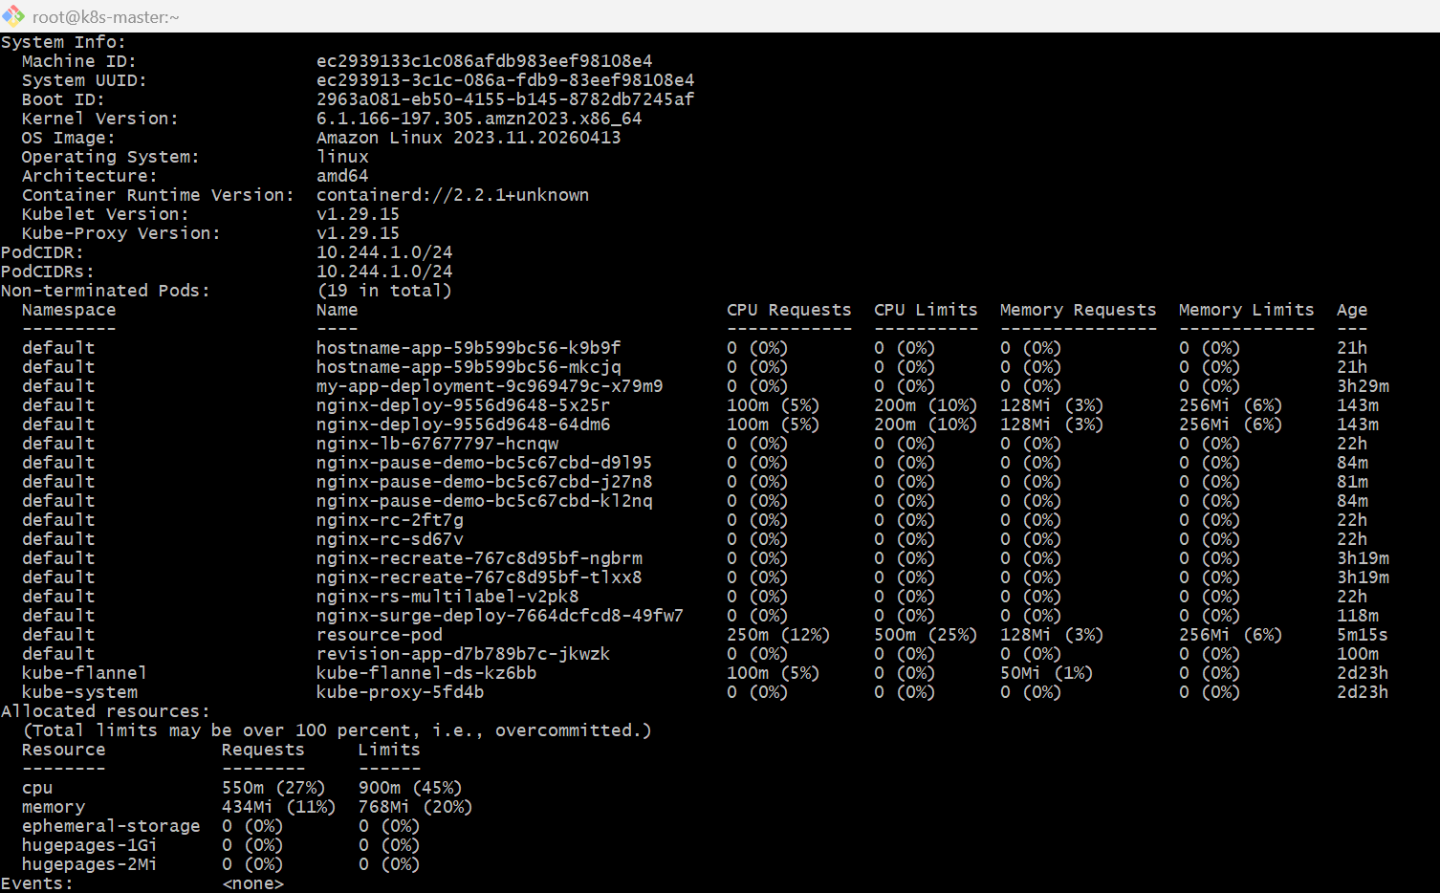
If you want to test scheduler failure
Use very high requests:
resources:
requests:
memory: "10Gi"
cpu: "5"
Then run:
kubectl apply -f resource-pod.yaml
kubectl get pods
